实验报告五 稀疏矩阵的存储和运算
班级： 姓名： 学号： 专业：

- 实验目的：
- 熟悉稀疏矩阵的存储方式
- 用三元组法实现稀疏矩阵的加、减、转置等算法。
- 实验内容：
1. 已知两个稀疏矩阵A和B，试基于三元组顺序表，编程实现A+B的运算，判断矩阵相等、判断对称矩阵、计算矩阵乘积。

算法原代码：
import java.util.*;
public class SparseMatrixOperations {
static class Triple {
int row; // 行号
int col; // 列号
int value; // 值
public Triple(int row, int col, int value) {
this.row = row;
this.col = col;
this.value = value;
}
public String toString() {
return "(" + row + ", " + col + ", " + value + ")";
}
public boolean equals(Object obj) {
if (this == obj) return true;
if (obj == null || getClass() != obj.getClass()) return false;
Triple triple = (Triple) obj;
return row == triple.row && col == triple.col && value == triple.value;
}
}
static class SparseMatrix {
private int rows; // 矩阵行数
private int cols; // 矩阵列数
private List<Triple> data; // 三元组数据
public SparseMatrix(int rows, int cols) {
this.rows = rows;
this.cols = cols;
this.data = new ArrayList<>();
}
public static SparseMatrix fromArray(int[][] matrix) {
if (matrix == null || matrix.length == 0) {
throw new IllegalArgumentException("矩阵不能为空");
}
int rows = matrix.length;
int cols = matrix[0].length;
SparseMatrix sparseMatrix = new SparseMatrix(rows, cols);
for (int i = 0; i < rows; i++) {
for (int j = 0; j < cols; j++) {
if (matrix[i][j] != 0) {
sparseMatrix.data.add(new Triple(i, j, matrix[i][j]));
}
}
}
return sparseMatrix;
}
public SparseMatrix add(SparseMatrix other) {
if (this.rows != other.rows || this.cols != other.cols) {
throw new IllegalArgumentException("矩阵维度不匹配，无法相加");
}
SparseMatrix result = new SparseMatrix(rows, cols);
int i = 0, j = 0;
while (i < this.data.size() && j < other.data.size()) {
Triple t1 = this.data.get(i);
Triple t2 = other.data.get(j);
int pos1 = t1.row * cols + t1.col;
int pos2 = t2.row * cols + t2.col;
if (pos1 < pos2) {
result.data.add(new Triple(t1.row, t1.col, t1.value));
i++;
} else if (pos1 > pos2) {
result.data.add(new Triple(t2.row, t2.col, t2.value));
j++;
} else {
int sum = t1.value + t2.value;
if (sum != 0) {
result.data.add(new Triple(t1.row, t1.col, sum));
}
i++;
j++;
}
}
while (i < this.data.size()) {
Triple t = this.data.get(i++);
result.data.add(new Triple(t.row, t.col, t.value));
}
while (j < other.data.size()) {
Triple t = other.data.get(j++);
result.data.add(new Triple(t.row, t.col, t.value));
}
return result;
}
public boolean equals(SparseMatrix other) {
if (this.rows != other.rows || this.cols != other.cols ||
this.data.size() != other.data.size()) {
return false;
}
for (int i = 0; i < this.data.size(); i++) {
if (!this.data.get(i).equals(other.data.get(i))) {
return false;
}
}
return true;
}
public boolean isSymmetric() {
if (rows != cols) return false;
Map<String, Integer> map = new HashMap<>();
for (Triple triple : data) {
String key = triple.row + "," + triple.col;
map.put(key, triple.value);
}
for (Triple triple : data) {
String symmetricKey = triple.col + "," + triple.row;
Integer symmetricValue = map.get(symmetricKey);
if (symmetricValue == null || symmetricValue != triple.value) {
return false;
}
}
return true;
}
public SparseMatrix multiply(SparseMatrix other) {
if (this.cols != other.rows) {
throw new IllegalArgumentException("矩阵维度不匹配，无法相乘");
}
SparseMatrix result = new SparseMatrix(this.rows, other.cols);
SparseMatrix otherTransposed = other.transpose();
for (Triple t1 : this.data) {
for (Triple t2 : otherTransposed.data) {
if (t1.col == t2.col) { // 相当于原矩阵的列 == 转置矩阵的行
int product = t1.value * t2.value;
if (product != 0) {
addToElement(result, t1.row, t2.row, product);
}
}
}
}
return result;
}
private void addToElement(SparseMatrix matrix, int row, int col, int value) {
if (value == 0) return;
for (int i = 0; i < matrix.data.size(); i++) {
Triple t = matrix.data.get(i);
if (t.row == row && t.col == col) {
matrix.data.set(i, new Triple(row, col, t.value + value));
return;
}
}
matrix.data.add(new Triple(row, col, value));
}

测试结果如下：
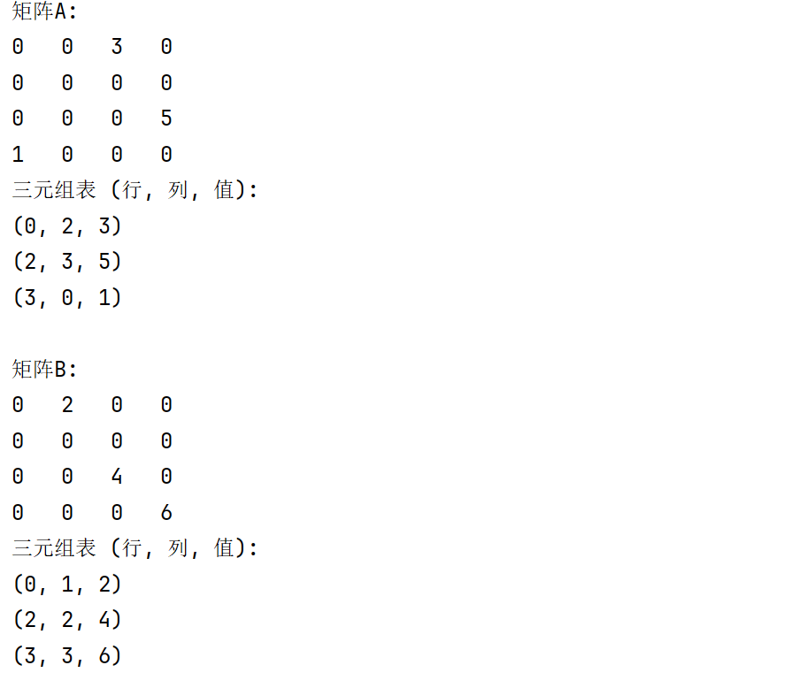
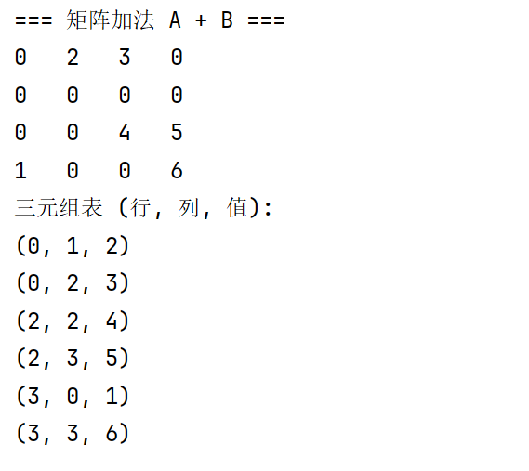
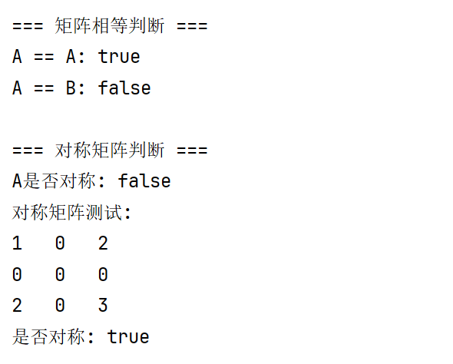
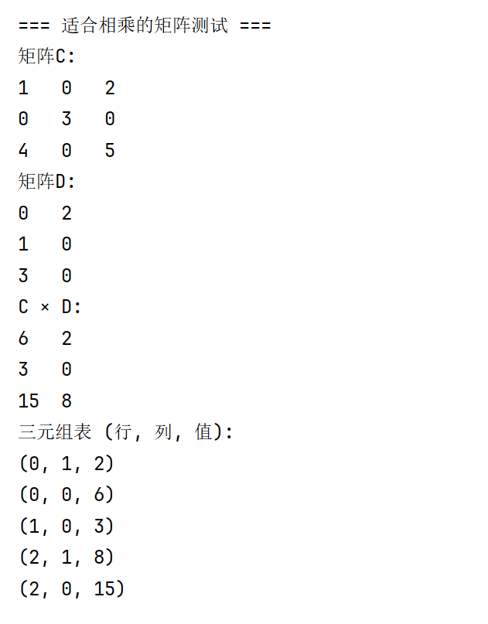

2、请用三元组表存储矩阵，并实现矩阵的转置。

算法原代码：
public SparseMatrix transpose() {
SparseMatrix result = new SparseMatrix(cols, rows);
// 创建转置后的三元组
for (Triple triple : data) {
result.data.add(new Triple(triple.col, triple.row, triple.value));
}
// 按行列排序
result.data.sort((t1, t2) -> {
if (t1.row != t2.row) {
return Integer.compare(t1.row, t2.row);
} else {
return Integer.compare(t1.col, t2.col);
}
});
return result;
}
public SparseMatrix fastTranspose() {
SparseMatrix result = new SparseMatrix(cols, rows);
// 初始化列计数和起始位置数组
int[] colCount = new int[cols];
int[] startPos = new int[cols];
// 统计每列的非零元素个数
for (Triple triple : data) {
colCount[triple.col]++;
}
// 计算每列在转置矩阵中的起始位置
startPos[0] = 0;
for (int i = 1; i < cols; i++) {
startPos[i] = startPos[i - 1] + colCount[i - 1];
}
// 初始化结果数组
Triple[] resultArray = new Triple[data.size()];
// 执行转置
for (Triple triple : data) {
int pos = startPos[triple.col]++;
resultArray[pos] = new Triple(triple.col, triple.row, triple.value);
}
// 转换为List
result.data = new ArrayList<>(Arrays.asList(resultArray));
return result;
}
public int[][] toArray() {
int[][] matrix = new int[rows][cols];
for (Triple triple : data) {
matrix[triple.row][triple.col] = triple.value;
}
return matrix;
}
public void print() {
int[][] matrix = toArray();
for (int i = 0; i < rows; i++) {
for (int j = 0; j < cols; j++) {
System.out.print(matrix[i][j] + "\t");
}
System.out.println();
}
}
public void printTriples() {
System.out.println("三元组表 (行, 列, 值):");
for (Triple triple : data) {
System.out.println(triple);
}
}
// Getter方法
public int getRows() { return rows; }
public int getCols() { return cols; }
public List<Triple> getData() { return data; }
}

测试结果如下：
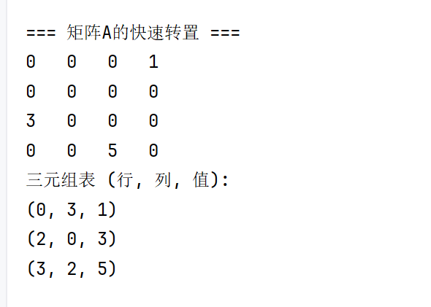

- 实验心得（含上机中所遇问题的解决办法，所使用到的编程技巧、创新点及编程的心得）

